A Tour of the EAST Web Site Technical Support Ticket System

We designed the Technical Support Ticket System to allow users to obtain technical support quickly and easily.

Figure 1: Home Page

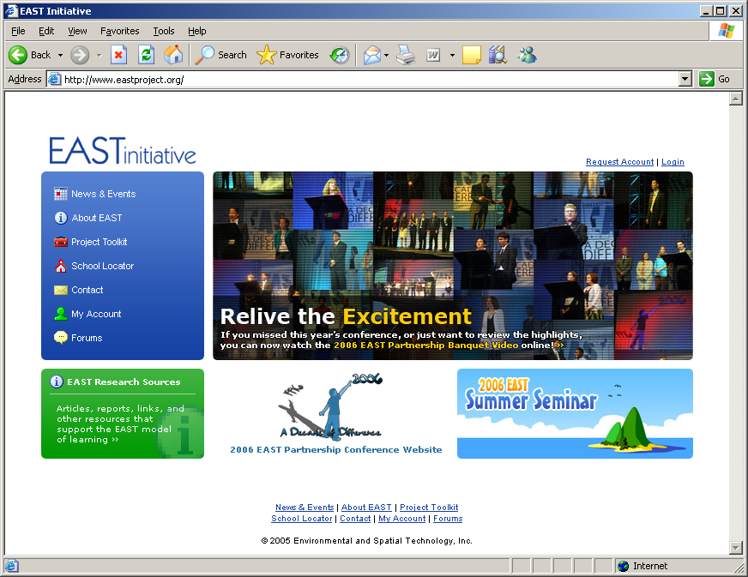

The first step is to navigate to the EAST Home Page as shown in Figure 1. http://www.eastproject.org.

At the home page, the user may login to the website using their assigned username and password. If the username and/or password is/are unavailable, a facilitator may reset the student’s password. Questions about usernames and passwords may be emailed to webadmin@eastproject.org.

After the user logs into the website, the screen will look similar to Figure 2.

Figure 2: User Account Page

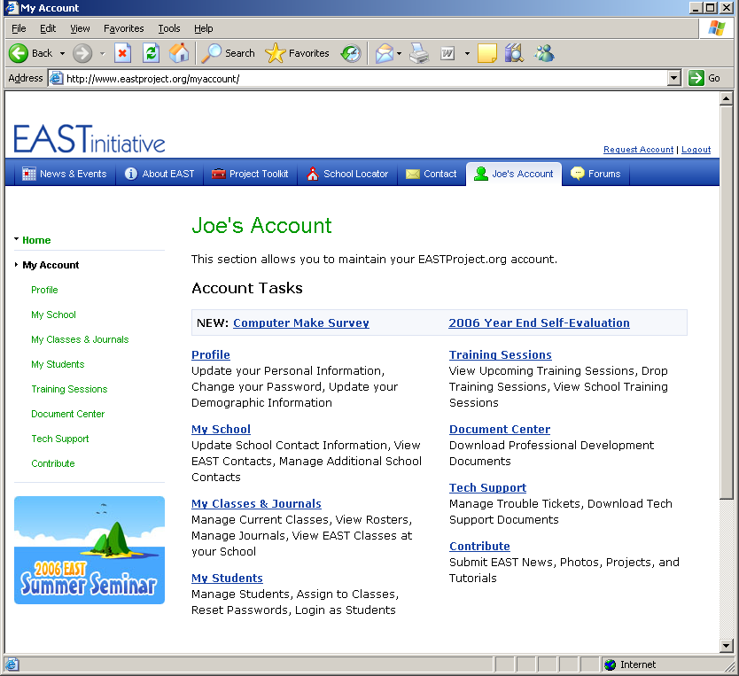

In Figure 2, note the Tech Support link located on the left side-menu or main menu item on center page. The user may click Tech Support to view all open and closed Technical Support Tickets. Facilitators may view all tickets which belong to their school whereas a student may only view tickets he/she has submitted.

Figure 3: Technical Support Ticket System

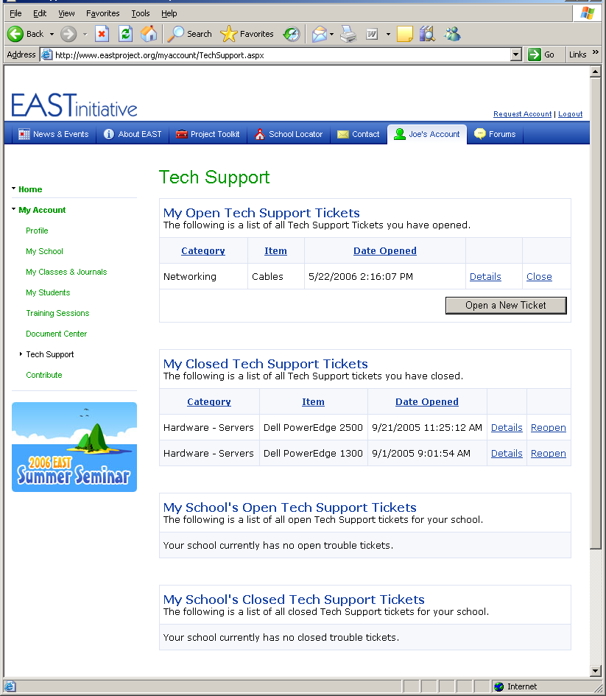

After the user selects the Tech Support link, the website will look similar to Figure 3. Note the user may view open and closed tickets. Additionally, facilitators may view open and closed tickets for the school. To close a ticket, the user may select the Close link. To open a ticket, the user may select the Reopen link.

Figure 4: Creating a Technical Support Ticket

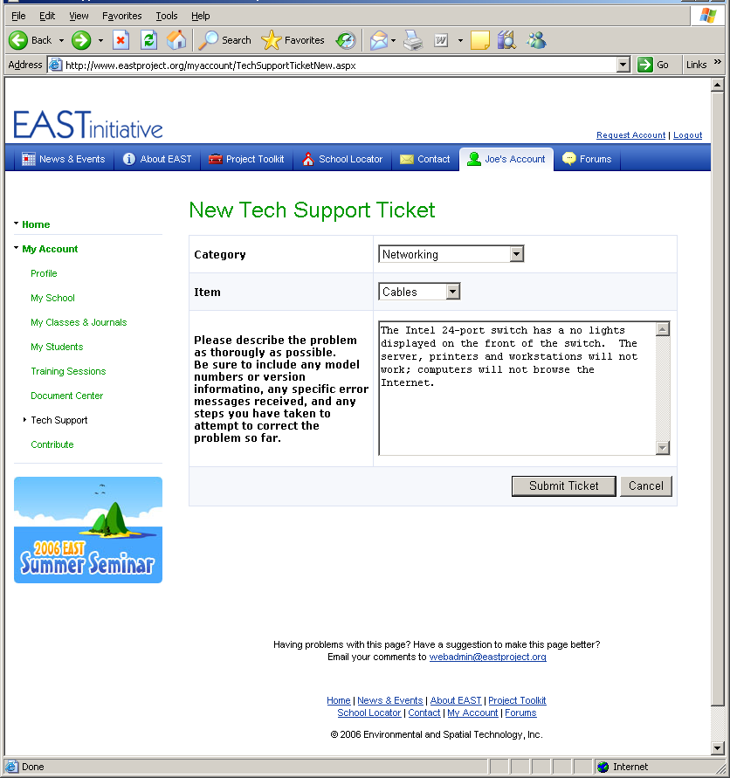

Figure 4 depicts a user opening a new Technical Support Ticket. The user may select a category and item and then provide a description of the problem. The user is encouraged to provide as many details as possible when describing the problem. Error messages, codes and problem symptoms are helpful.

After a user selects the category and item and provides a description, he/she may click the Submit Ticket button.
Figure 5: Viewing a Support Ticket

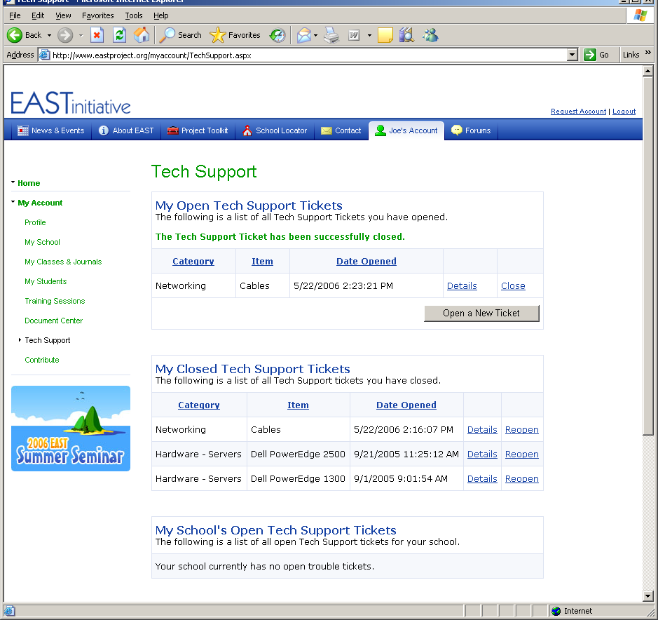

After a ticket has been opened, a EAST staff member will reply. Most tickets have a response within 30 minutes of activity. To view the response, click the Details link.

Figure 6: Viewing Support Ticket Responses

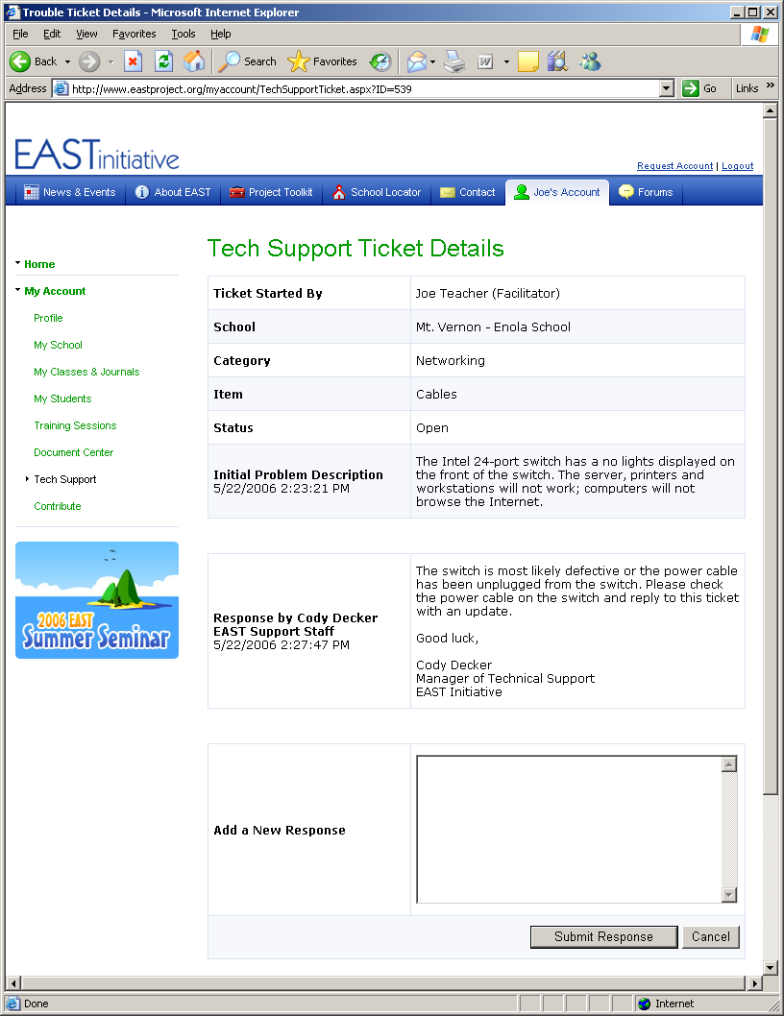

As shown in Figure 6, the user may view the EAST staff member response by clicking the Details link. After reading the response and following the provided directions, the user should reply to the ticket with an update on the problem status as depicted in Figure 7.

Figure 7: Response to Technical Support Ticket

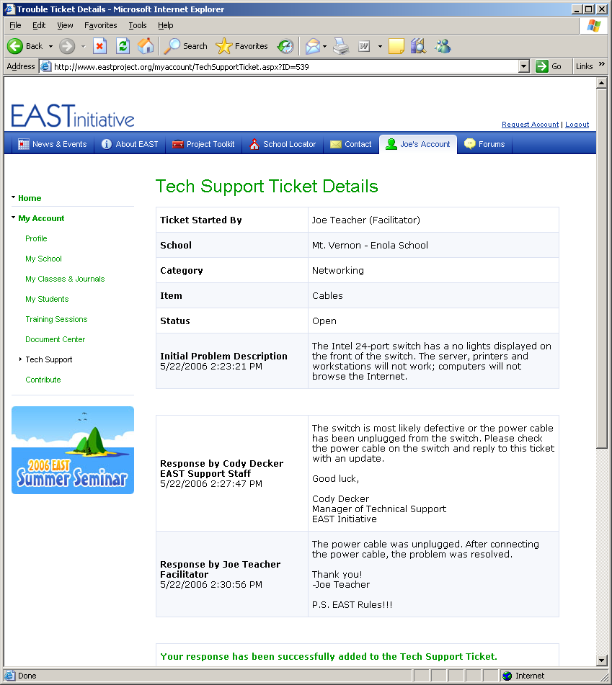

After the problem has been resolved, the user is encouraged to close the Technical Support Ticket.

Figure 8: Closing Technical Support Ticket

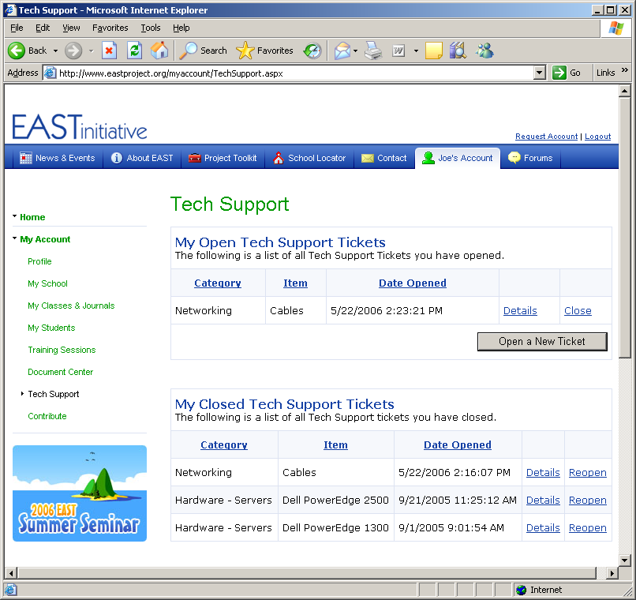

The user may close the ticket by clicking the Close link. The ticket will then be considered closed/resolved and will be available for future reference under My Closed Tech Support Tickets.

Please remember to use the Technical Support Ticket System for all technical support requests. Additionally, keeping the ticket system up-to-date and timely replies to the ticket will ensure you and your students receive efficient and effective technical support.

EAST Technical Support
Technical Support Tickets: http://support.eastproject.org (Preferred)
Email: support@eastproject.org
Phone: (501) 371-5016

